Welcome!
Date
Name
Spouse
Address
City
State Zip _________
Email

Please Contact By
❑ Card  Phone  Visit

Telephone Best Time to Call
Home ______________
Work ______________

Guest: First Time Second Time
Are you a church member: yes no
Church
City, State

Circle Appropriate Age/Grade Group(s)
Preschool: Ages: B-1 2-3 4-5
Children: Grades: K 1 2 3 4 5 6
Youth: Grades: 7 8 9 10 11 12
Adults: Ages:18-29 30s 40s 50s 60s+

How did you learn about our church?
Newspaper Friend Yellow Pages Mail
Other

I am a guest of:

New in the Community? Yes No
Names & ages of children at home

Weekly Service & Activity Schedule

Nov 20, 2016
9:45 a.m. Sunday School
11:00 a.m. Worship Service
12:00 p.m. New Commandment Kids
6:00 p.m. Evening Service

Week of Nov 20, 2016

There will not be Wednesday evening Bible Study

December
4…..New Commandment Kids go to Elgin Nursing Home
4……………………………Spiritlifters SS Christmas Party
6……………………………………..……..Ladies Craft Night
4-11……..………Week of Prayer for Lottie Moon Missions
8………………………………..…………….Adult Fellowship
11………………………………..Church Christmas Program
16………………………………..Adult I SS Wrapping Party
New Commandment Kids

Will meet today after church in the Fellowship Hall to learn Christmas songs and make nursing home decorations. Kids will be ready for pick up by 3:00 pm. Lunch will be provided.


Join us for a Ladies Craft Night!!
Tuesday, Dec. 6 @ 6:30
We will be making Christmas cards for wounded warriors. The cost is $5/person to cover supplies and postage. Contact Brenda Williams if you want to attend so she can have the appropriate amount of supplies.


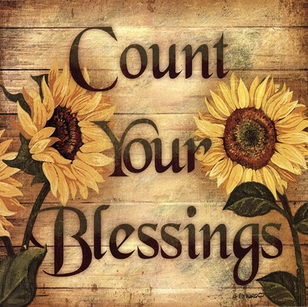

Knobbs Springs Baptist Church

November 20, 2016

Church Information:

KnobbsSpringsBC.com KnobbsSpringsBaptist@gmail.com

1662 CR 305, McDade, Texas 78650 512-273-2743

David Atwood, Pastor Cell 512-470-5098

Patti Radford, Office Manager Cell 512-968-7821

